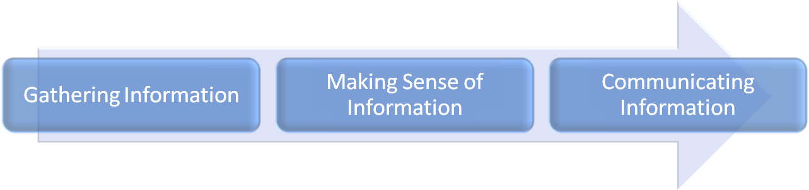
How Students Learn

Characteristics of Effective Instruction
Strategies
21st Century Learning and Innovation (Thinking) Skills

Phases of Thinking and Learning

